Note: In this case I have created a material with Number BDC_MAT1 and changed it to BDC_MAT2 later.

Participants may create any material number.

1. Go to SM35. Click on the Recording button.

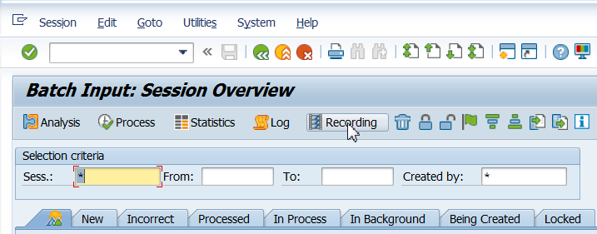

1. Click on New Recording.

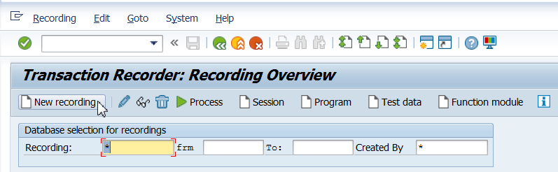

1. Enter details as shown below.

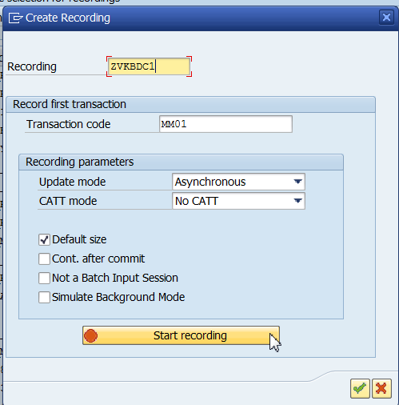

1. Perform the following steps for recording:

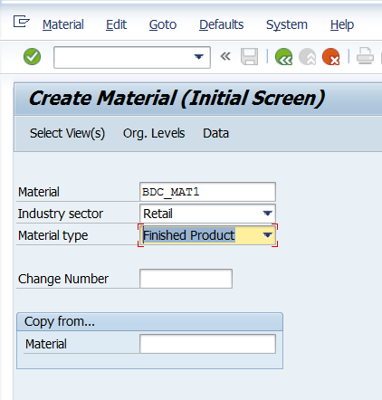

Press Enter.

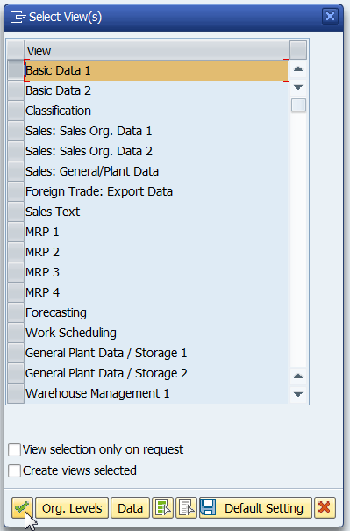

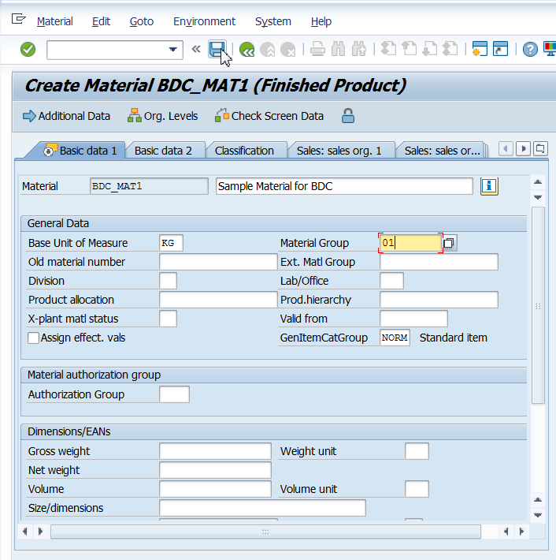

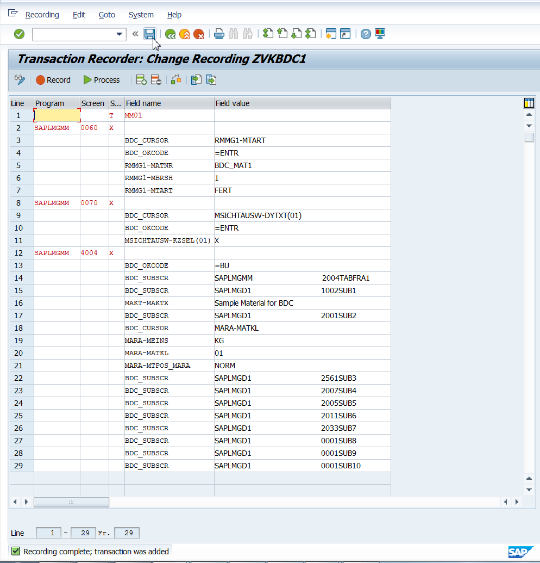

Save. Go back.

Click on program.

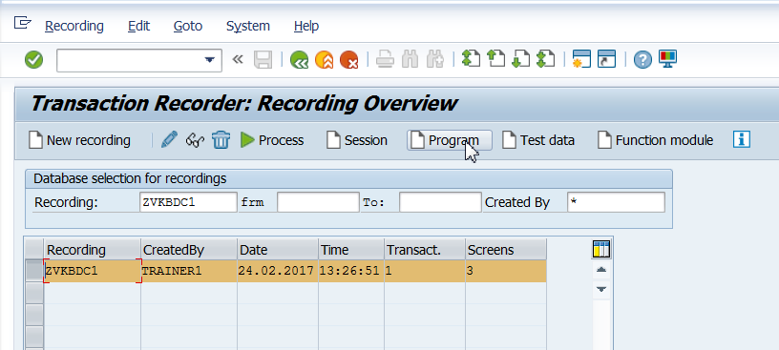

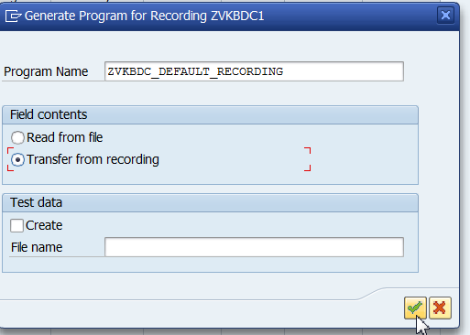

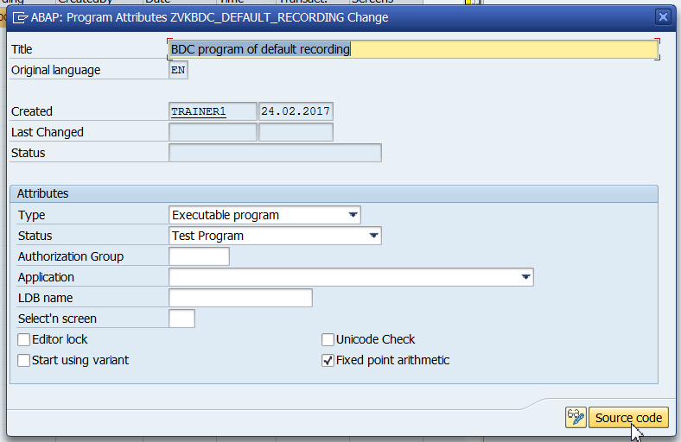

Save the program in package and view it in SE38.

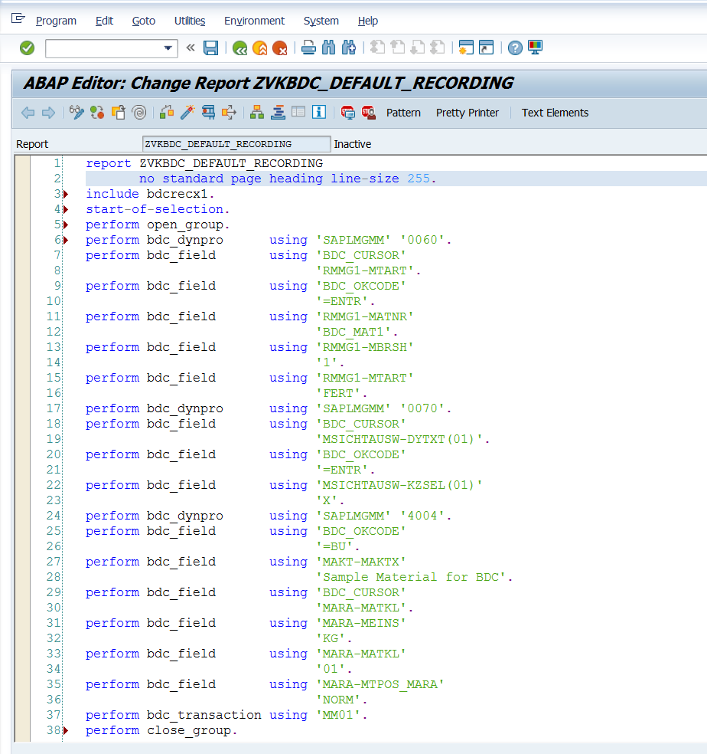

1. Go to MM02. Enter the Material as BDC_MAT1(given above).

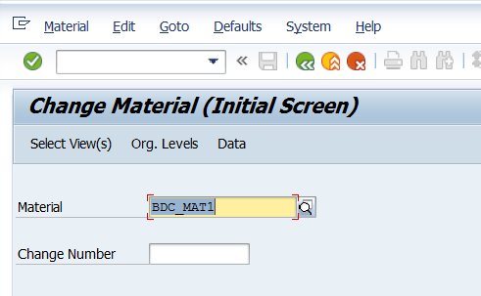

1. Press Enter. Select Basic Data1. Press the green tick

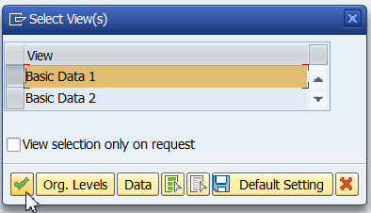

1. This will display the record BDC_MAT1.

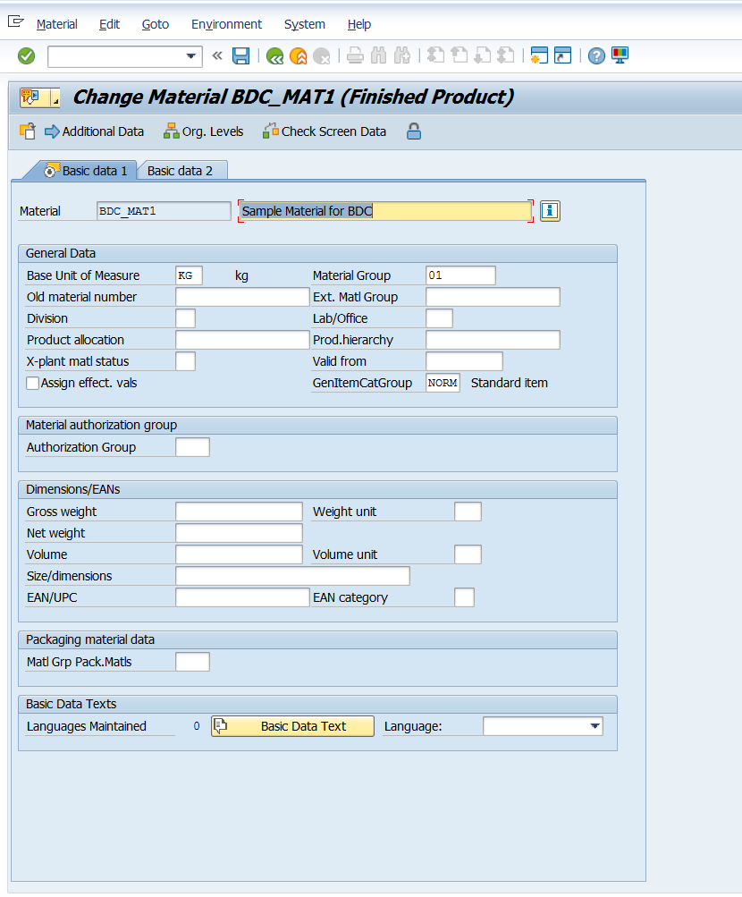

This implies that the material with the number BDC_MAT1 has already been created. So if the same program of default recording is executed, it would give error as the material already exists.

1. Hence change from BDC_MAT1 to BDC_MAT2 and execute the SE38 program.

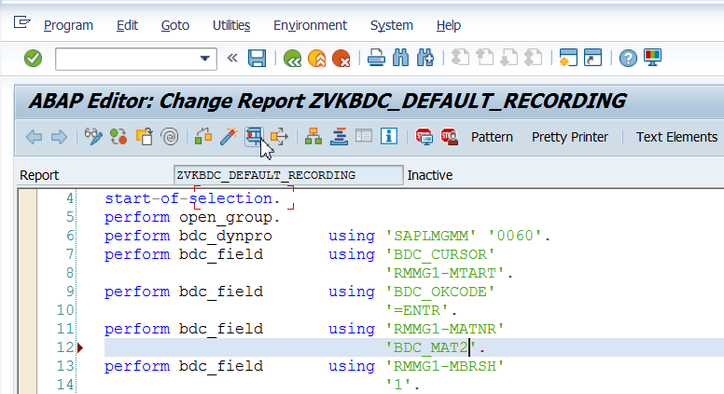

1. Give the session name, select the check box on keep session and execute.

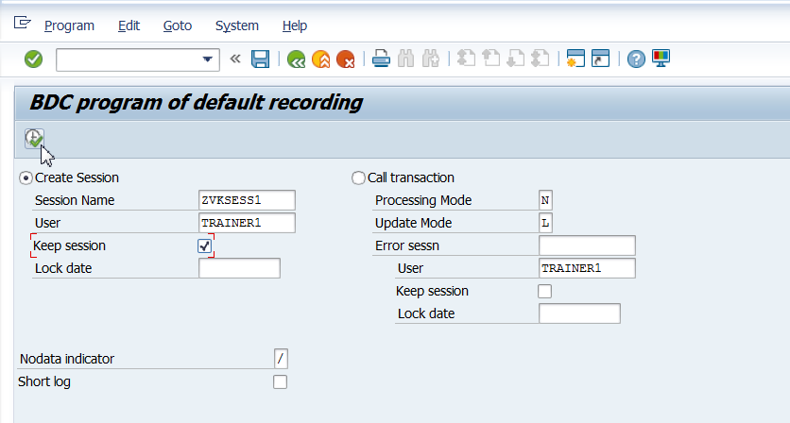

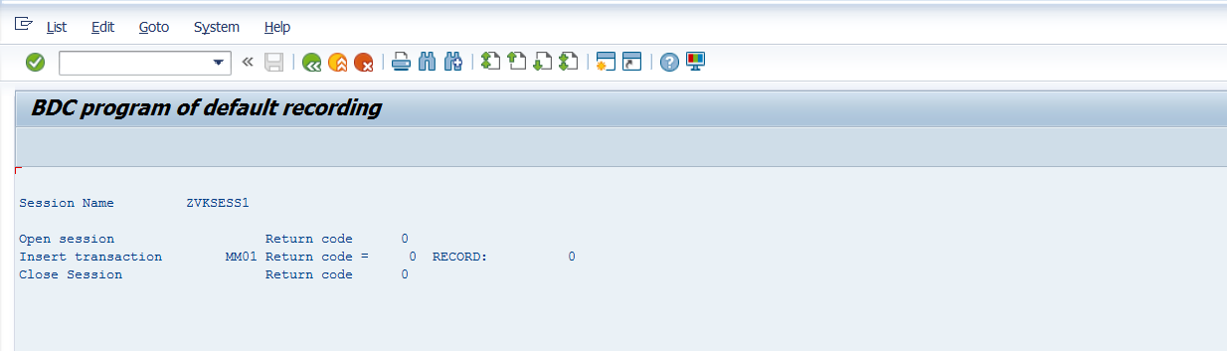

Note: The material has still not been created and you cannot see it in MM02. The session has to be executed.

1. Go to SM35.

Select the session and click on process. The below steps navigate through the various screens of MM01. Just click on green tick and continue till you see the Information Message “ Processing of batch Input session completed” and come to the screen of SM35.

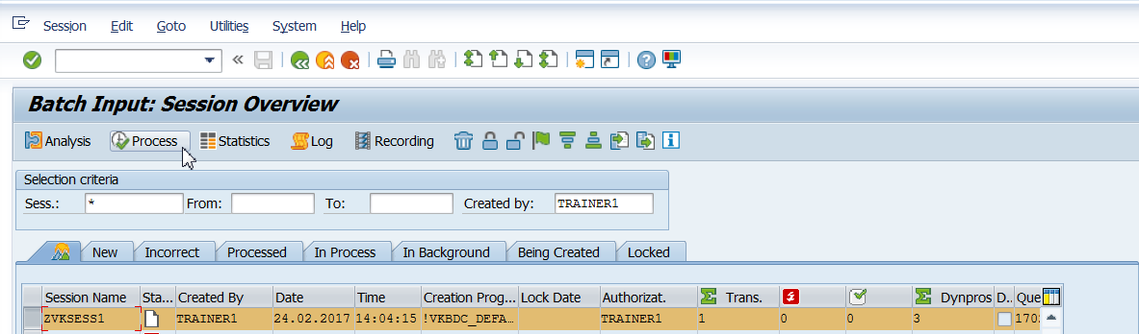

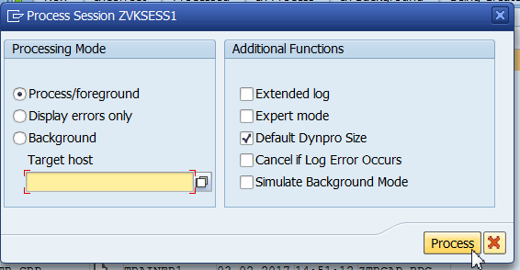

1. Observe the steps

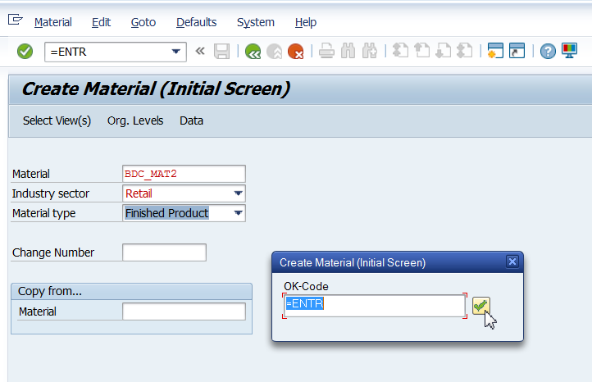

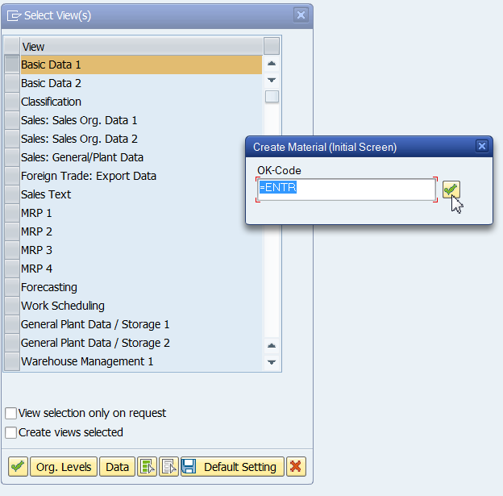

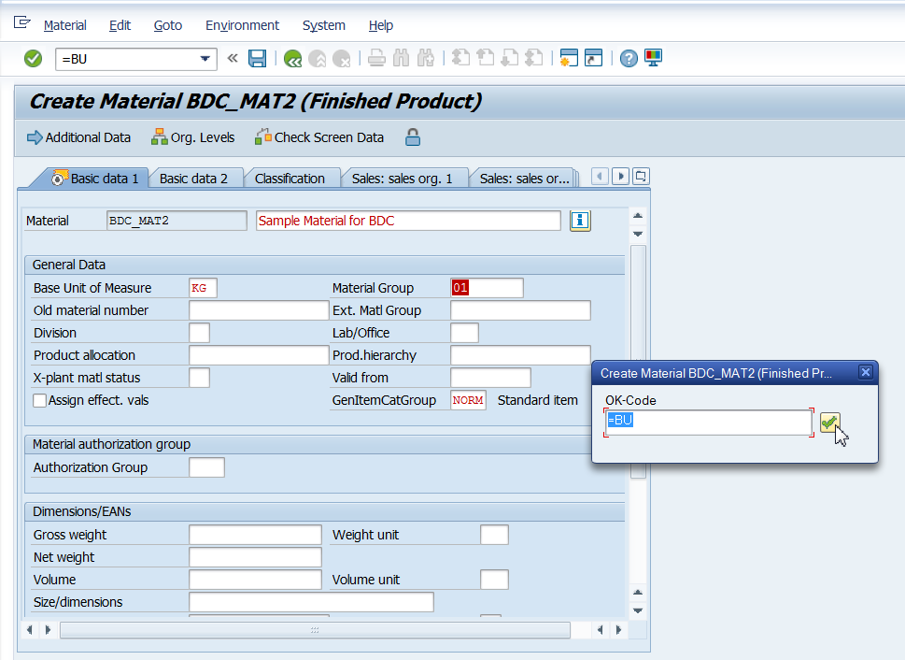

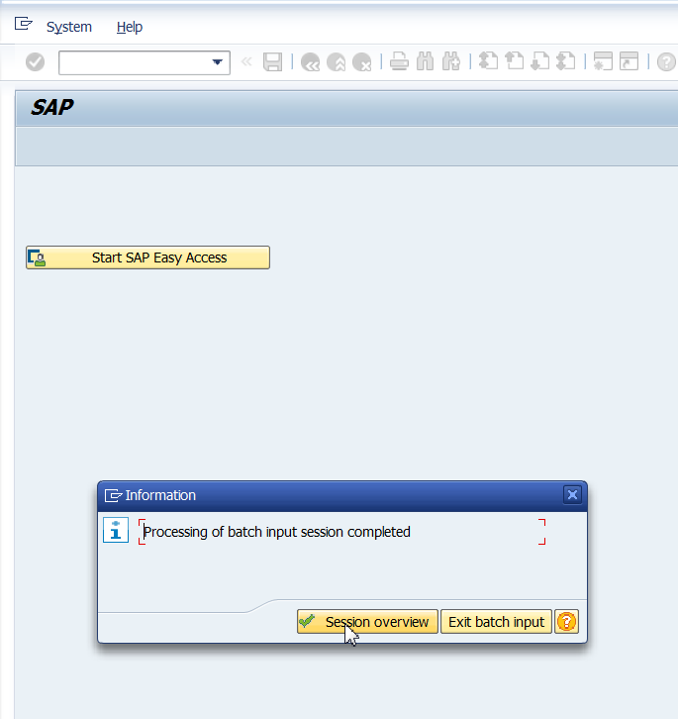

1. This brings you back to SM35 and you observe the status of session.

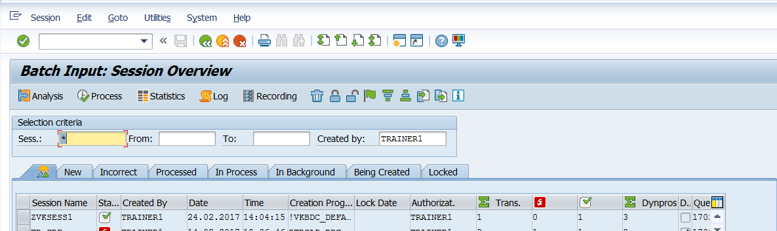

1. Go to MM02 and verify that BDC_MAT2 has been created.